Peter Fjällman elected as Senior Member in EIGCA

Fjällman Golf Design

Pressannouncement

DATUM: 2008-04-15
As the first swedish Peter Fjällman has been elected as Senior Member in The European Institute of Golf Course Architects. He was elected in connection to the Institutes early meeting in Girona last week.
”I’m very pround to become a Senior Member in EIGCA and it is a bit special to be the first swedish golf course architect that has reach this level of membership” Fjällman informs.
”I’m one of the few within the Institute that has gone the whole way from student to the highest level of membership in a short period.”
Fjällman has been a member of the Institute since 2002 and he is also a member of the board where he is handling the finance. ”The Institute has grown stronger and stronger for each year, not only financually, but also as the most influenceally institute in Europe for golf course architects. And every year we expand on our global contacts. Thus the planning is now heading for World Golf Forum i St Andrews 2010” Fjällman finishes’.

Lotsvägen 24
184 92 Åkersberga
Sweden
Telefon: +46 (0) 8 540 26365
Mobil: +46 (0) 70 765 83 30
E-postadress: peter.fjallman@telia.com
www.fjallmangolfdesign.com

Fjällman Golf Design
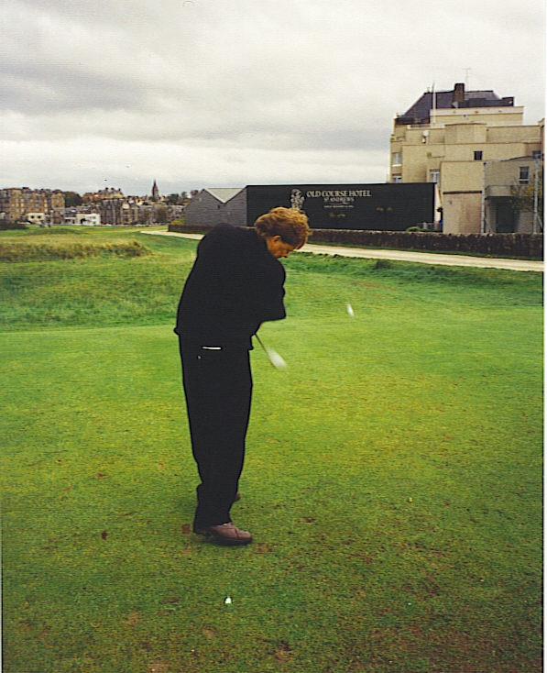
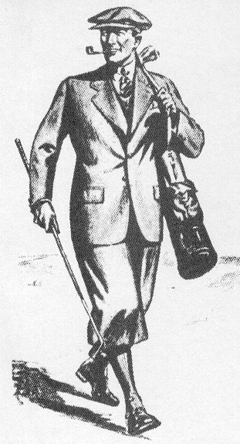

Peter Fjällman
Senior Member of The European Institute of Golf Course Architects EIGCA

Member of Föreningen Skandinaviska Golfbanearkitekter FSGA

Professional Diploma in Golf Course Architecture (with distiction) issued by EIGCA 2002.
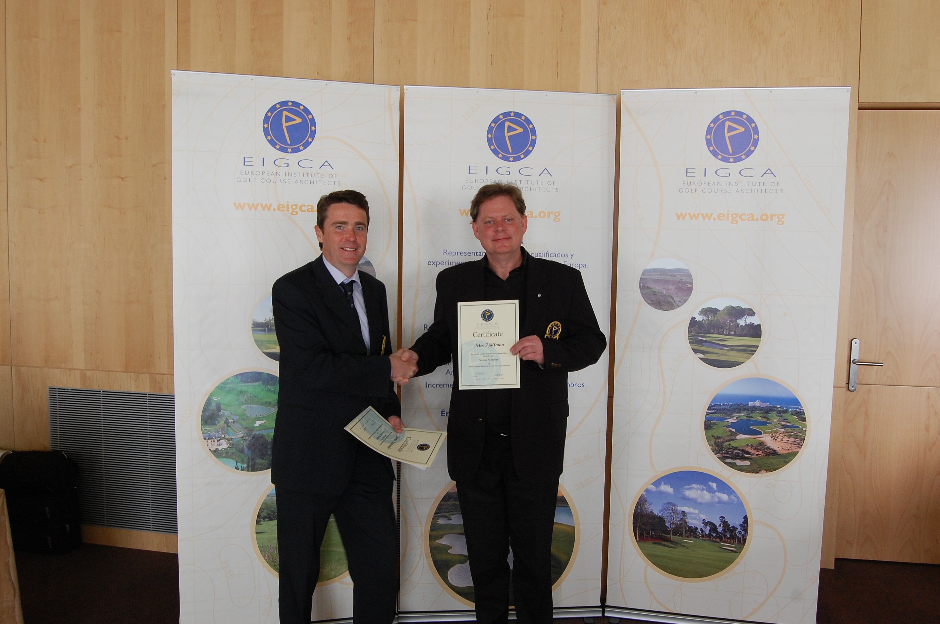
Ken Moodie (t.v.) chairman in EIGCA hands the diploma to Peter Fjällman as evidence on a Senior Membership in EIGCA

